
Khulna University of Engineering and Technology
Course Title: Digital signal processing Laboratory
OPEN ENDED PROJECT
Project Report ON: Explore the fundamental characteristics of FIR filter and analyze the frequency response of noisy and enhanced sample by user defined function.
COURSE NO: ECE -3204

Submitted TO:  Prof. Dr. sheikh Md. Rabiul Islam  Professor  Department of ECE  Mr. Shah Muhammad Azmat Ullah  Assistant Professor  Department Of ECE | Submitted By:  MD. kayed ibnet  Roll:2009053  Department: ECE

Objectives:
The primary objectives of this project are:
- To understand the fundamental characteristics of Finite Impulse Response (FIR) filters.
- To design and implement user-defined functions for FIR filters.
- To analyze the frequency responses of noisy and enhanced samples.
- To evaluate the performance of FIR filters in noise reduction and signal enhancement.

Introduction:
FIR filters are a type of digital filter widely used in signal processing due to their inherent stability and linear-phase properties. They are fundamental in applications such as audio processing, communication systems, and biomedical signal analysis. This project aims to design FIR filters using user-defined functions and examine their impact on noisy signals by analyzing their frequency responses. FIR filters have several advantages over IIR filters because of linear phase response, stability, simpler design.
The impulse response of an FIR (Finite Impulse Response) filter is a fundamental characteristic that defines its behavior.
Mathematical Representation of an FIR FILTER:
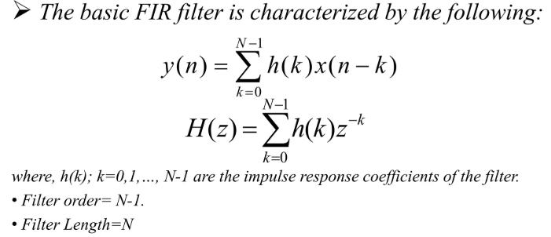

Transfer function:
The transfer function of a filter is the Z-transform of its impulse response. For an FIR filter, the Z-transform of the output y,
Y(z), is the product of the transfer function and X(z), the Z-transform of the input x:
Y ( z ) = H ( z ) X ( z ) = ( h ( 1 ) + h ( 2 ) z − 1 + ⋯ + h ( n + 1 ) z − n ) X ( z ) .

Theory:
FIR (Finite Impulse Response) filters can be designed using different methods. Each method has advantages and trade-offs depending on filter length, frequency response, and complexity.
- Windowing Method:
  - Apply a window function (e.g., Hamming, Hanning, Blackman) to truncate the ideal impulse response.
  - Advantages: Simple and computationally efficient.
  - Disadvantages: Limited control over the frequency response.
The window method is a popular and simple technique for designing FIR filters. It is widely used because of its simplicity, effectiveness, and ease of implementation.
- Simplicity and Ease of Implementation
- Control Over the Stopband Attenuation and Transition Width
- Design of Linear Phase Filters
- Stability of the Filter - The window method preserves this stability since it directly truncates the ideal impulse response.
- Computational efficiency - Designing filters using the window method does not require solving large systems of equations or performing iterative optimizations.

- Frequency Sampling Method:
  - Specify the desired frequency response at specific frequencies and interpolate.
  - Advantages: Precise control over specific frequency points.
  - Disadvantages: Can result in ripples or deviations in the frequency response.
Trade-offs:
- Filter Length: Longer filters offer better frequency selectivity but increase computational complexity.
- Window Functions: Choice of window affects the stopband attenuation and transition width.
- Computational Complexity: Optimal methods yield better performance but require more resources.

Required Software:
MATLAB
Version: R2023a
Purpose: Filter design, simulation, and analysis

Design and Implementation:
The design and implementation of an FIR filter involves specifying its requirements, selecting an appropriate design method, and implementing it using mathematical tools or software. Here is a complete guide to designing and implementing an FIR filter:
Before designing an FIR filter, clearly define the filter specifications based on the desired application:
- Filter Type:
  - Low-Pass Filter (LPF)
  - High-Pass Filter (HPF)
  - Band-Pass Filter (BPF)
  - Band-Stop Filter (BSF)
- Cutoff Frequency (or Band-edge Frequencies for BPF/BSF)
- Sampling Frequency fs
- Filter Length (Order) NNN:
The filter order depends on the transition band and attenuation requirements.
Block Diagram of the Implemented Design:
Start
Input Parameters:
Filter-Type: Band Pass
Passband: 1500 – 2750 Hz Lower Stopband: 0-1KHz
Upper Stopband: 3.5-4.5KHz
Sampling rate: 8KHz
Passband Ripple: 0.5 dB
Stopband Attenuation: 40 dB
Determine applicable Window and Filter coefficient
Noisy Signal
Determine the required operations with the user defined functions
Filtered Signal
END

Calculate proper window function

Plot Magnitude Response, Phase Response,
Pole-Zeros (For Stability Check) and Display transfer function

Figure 3.1: Block Diagram of designed Band Pass FIR filter

Result Analysis:
Stability:
FIR filters are inherently stable since they rely on non-recursive structures.
Frequency Response:
- Noisy Signal: The frequency spectrum of the noisy signal before filtering shows high-frequency noise.
- Filtered Signal: After applying the FIR filter, the noise is suppressed, and the desired frequency content is preserved.

Discussion:
In this project we design an FIR filter and analyze the frequency response of noisy an enhanced samples using user defined function. At first we input a noisy audio signal then we filter this signal using FIR filter. We take input parameter from user then design the design the filter to remove noise from the audio signal. The frequency spectrum of the original noisy signal displayed significant unwanted high-frequency components. After applying the FIR filter, the noise was attenuated in the stopband, and the desired signal in the passband was preserved.
While FIR filters are simple to design and implement compared to IIR filters, several challenges arise during their practical use. Firstly we require Filter Length (Order) Requirements . FIR filters require a higher filter order compared to IIR filters to achieve the same level of frequency selectivity. Trade-off Between Stopband Attenuation and Transition Width: The window method allows for various trade-offs by selecting different window functions. Apart from those problem We have successfully design our FIR filter which will remove the noise from the audio signal perfectly.

Conclusion:
FIR filters are fundamental in digital signal processing due to their linear phase, stability, and ease of design. We have use window method which is an effective approach for FIR filter design, balancing simplicity and performance. By implementing user-defined functions, we analyzed the frequency response of both noisy and enhanced signals, demonstrating the effectiveness of FIR filters in suppressing unwanted noise.

END

